Albuquerque Environmental Health Department (EHD)
Air Quality Programs (AQP)
Ambient Air Monitoring Section
2014 Annual Network Review for Ambient Air Monitoring

Under 40 CFR, Part 58, Subpart B, The City of Albuquerque Air Quality Programs (AQP) is required to submit an annual monitoring network review to the Environmental Protection Agency (EPA) regional office in Dallas, Texas. Our objective, when preparing the report, is to optimally apply limited resources to best protect public health.

The network plan describes the framework of the local air quality surveillance system, presents monitoring results over the past three years, provides comparisons to National standards, and discusses future plans. The annual monitoring network plan must be made available for public inspection for at least 30 days prior to formal submission to EPA. (Anticipated dates are May 30 – June 30, 2014.)

This document shows the current network configuration and proposed changes for 2014. It represents the commitment of the AQP to effectively protect the health of the citizens of Albuquerque-Bernalillo County through ambient air monitoring, by using the best affordable technology, and by communicating the data collected as quickly and accurately as possible.

Two monitoring sites, 2ZH North Valley (AIRS 35-001-1013) and 2ZT Taylor Ranch (AIRS 35-001-0027) were shut down in 2013 with EPA Approval. Those sites housed four monitors (two Ozone, one PM10 and one PM2.5) but we continue to meet our minimum requirements for each criteria pollutant.

Additional monitor and site cutbacks are proposed for the upcoming year, developed in consultation with EPA Region VI to better align the network with minimum network requirements. Changes will be discussed by pollutant in each section.

Population Statistics
Albuquerque/Bernalillo County, including Rio Rancho and Los Lunas is the State’s largest Metropolitan Statistical Area (MSA). The US Census Bureau estimates the 2013 population of the metropolitan statistical area (MSA) which includes portions of the adjacent counties of Sandoval, Valencia, and Torrance as approximately 902,797 (43.3% of the State). http://quickfacts.census.gov/qfd/index.html# As the regional center for employment, advanced education, retail commerce, and medical treatment, Albuquerque experiences non-local commuter traffic. The junction of major Interstate 25 (north/south) and Interstate 40 (east/west), adds significant heavy transport traffic between the port of Los Angeles and the East Coast, and between Denver, El Paso, and the US-Mexico Border. However, this traffic is less significant when compared major metropolitan areas.

The map in Figure 1 shows the physical location of all current monitoring sites currently operated by the Air Quality Programs. Three sites are within the city limits of Albuquerque. Three other sites (2ZV - South Valley, 2ZW Westside, and 2ZF - Foothills) are in Bernalillo County.
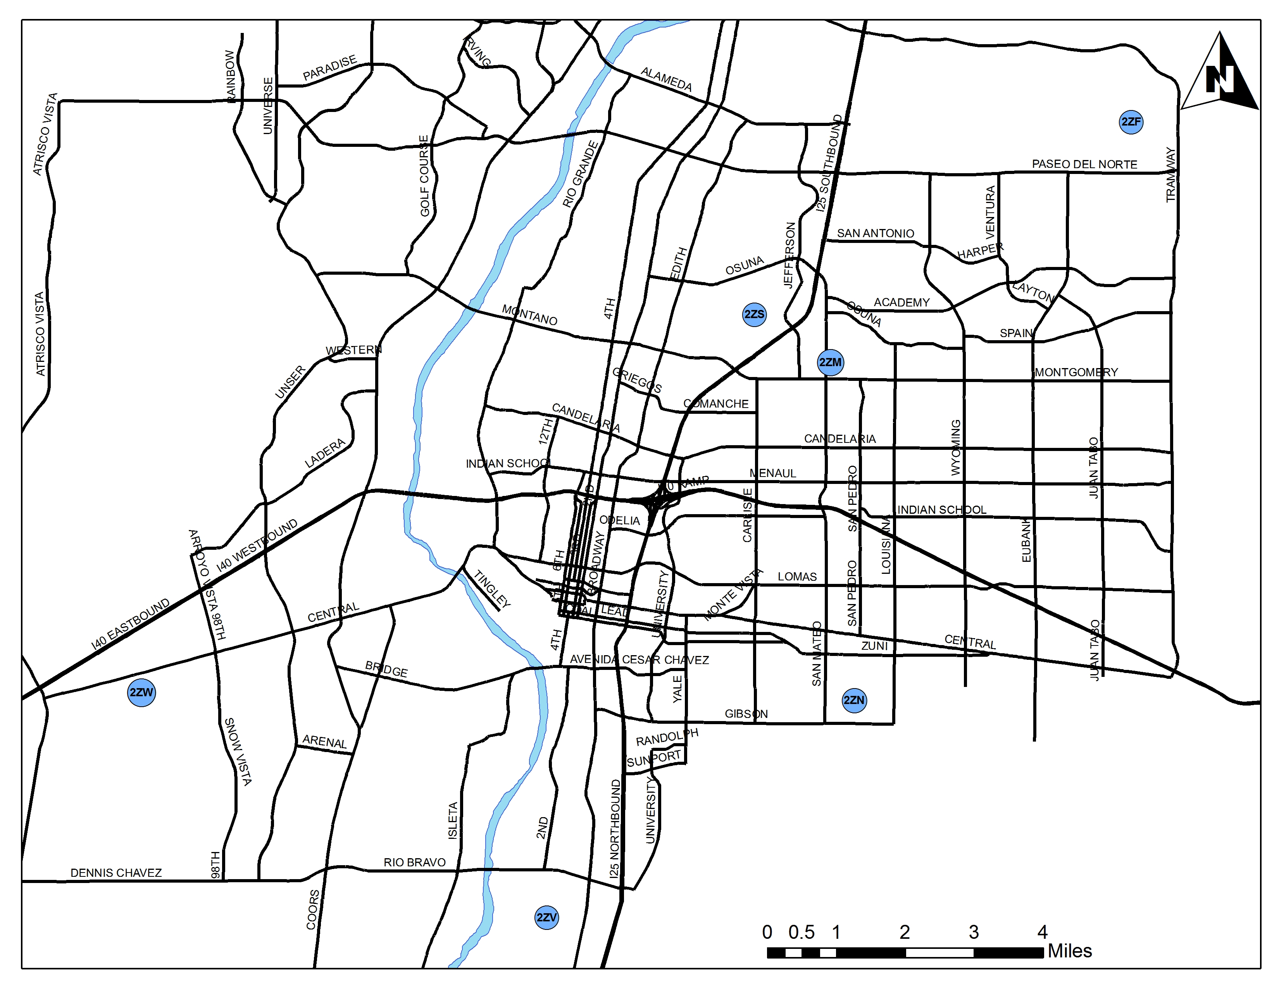
Figure 1: Albuquerque Ambient Air Quality Monitoring Network

Table 1 shows the current network configuration and lists the monitoring equipment operated at each site. Column 1 is the “AQS Site ID#,” a unique identification number assigned to each monitoring site in the network. The AQS (Air Quality System) is a national air monitoring database maintained by the EPA. Data collected from monitoring sites are input into the AQS database within 90 days following the end of each calendar quarter. <http://www.epa.gov/ttn/airs/aqsdatamart/access.htm>

Column 2 gives the local site designation, name, location, and “affiliation.” Site longitude and latitude are in columns 3 and 4. Columns 5 through 9 list the monitors at each site and their associated parameters. Site photographs accompany the hard-copy version of this report on CD. During the public review period monitoring site photographs can be downloaded from the City of Albuquerque – Air Quality Programs website http://www.cabq.gov/airquality/

Proposed changes to the network are discussed in the next section, by pollutant.
Table 1 Albuquerque 2013 Ambient Air Monitoring Network

Table 1 - Continued
*Siting criteria are not good for PM SLAMS but the site is necessary for AQI.

Summary of changes
Changes proposed for the upcoming year were developed in consultation with EPA Region VI, to better align the network with minimum network requirements.

Ground Level Ozone (O3)
Based on population, Table D-2 of Appendix D to Part 58, 40 CFR specifies a minimum of two (2) SLAMS (State and Local Air Monitoring Stations) ozone monitors.

Current – Currently the AQP exceeds the minimum requirements with five (5) ozone monitors, all categorized as SLAMS.

The MSA experiences high levels of Ozone during the summer and non-attainment is a serious consideration. Our declaration in 2013 did not show an exceedence of the standard but the matter must be re-examined every year. There was great concern about 2013 but we experienced very unusual weather patterns. Table 2 shows that for the first time in many years Ozone levels dropped instead of rising.

Table 2: Ozone Design Value, ppm

Future – Two Ozone monitors at 2ZN SE Heights (AIRS 35-001-0024) and at 2ZW Westside (AIRS 35-001-0032) are proposed to shut down in 2014.

PM_{2.5}
According to Table D-5 of Appendix D to Part 58, 40 CFR two SLAMS PM_{2.5} sites (3 monitors) are required in Albuquerque.

Current – AQP operates four PM_{2.5} monitoring sites in Albuquerque-Bernalillo County with five (5) total monitors, all of which are identified as SLAMS.

The 2ZM site (35-001-0023) operates a Partisol 2025 sequential sampler with 2.5 micron inlet cutoff to record 24-hour averages PM_{2.5} on a 1/3 schedule. This sampler is a Federal Reference Method (FRM) and is comparable to the NAAQS. In the coming year this will be switched to a newer Partisol 2025i.

Beginning January 2012 and continuing through the present, two BAM 1020 continuous monitors have been used at site (35-001-0023) to report PM_{10-2.5} on an hourly basis. The PM_{2.5} BAM is collocated with the previously mentioned Partisol 2025 FRM.

Three additional sites monitor PM_{2.5} continuously. 2ZF and 2ZN, and 2ZV are SLAMS and are NAAQS comparable. The data from these monitors are used for the Air Quality Index (AQI) and report hourly averages that are sent to EPA’s AIRNOW web page for real-time Air Quality particulate mapping.

The 2013 98th percentile data in Table 3 show slight decrease over prior years. While it was an active Western fire season in general, we were fortunate in that there were fewer significant smoke intrusions into the Albuquerque airshed. However, it should be noted that the long range forecast for the 2014 fire season is very poor.

Future –The 2ZN Southeast Heights (AIRS 35-001-0024) continuous PM2.5 monitor is proposed to shut down in 2014. In conjunction with the Ozone discontinuation above, the Southeast Heights monitoring site will be closed.

Table 3: PM_{2.5} Design Value, ug/m3

PM₁₀
PM data is used by the AQI to accurately portray PM in neighborhoods, to enforce our local dust control regulation, and to issue high wind advisory and health alerts. High PM values are the most common cause of AQI warning days in Albuquerque.

Because of terrain, extremely dry climate, and unusual weather patterns, Bernalillo Co frequently has very different conditions in various parts of the airshed. Prevailing westerly winds are the assumed weather pattern but that is only true during certain seasons of the year and varies widely from site to site. East canyon winds accelerate down-slope on the Sandia Mountain at speeds up to 65 miles per hour, blasting the NE quadrant of the city before slowing and dispersing. East winds can also affect South Valley (AQS 35-001-0029 SV) with silt particulates from the outflow of the dry Tijeras Canyon. The Rio Grande river valley experiences North-South flow with a diurnal pattern. The west side of the city has very fine soils and large tracts of native vegetation are being removed for development. The combination of these factors can produce high PM levels with any wind direction and the manifestation varies from area to area.

Current – Over the past year the AQP monitored PM₁₀ at four sites with a total of 6 monitors. At this time, three of the sites and five monitors are NAAQS comparable.

The NCore Site 2ZM (AQS 35-001-0023) operates a continuous FEM that produces data used for both PM₁₀ and PM_{10-2.5}.

The AQP operates two PM₁₀ FRMs (1/1 & 1/6) and a continuous monitor at 2ZS (35-001-0029) all of which are NAAQS comparable.

The North Valley site 2ZH (AQS 35-001-1013) was shut down at the end of March, 2013 with EPA’s concurrence.

The status of the PM10 monitor at 2ZV (AQS 35-001-0029) was upgraded to SLAMS starting 1/1/2011 after site remediation and as of this year it has 3-years of valid data.

The AQP operates a PM10 a continuous monitor at 2ZW (AQS 35-001-0032) however, the PM siting criteria for site 2ZW are not met, and PM10 data is not be compared to the NAAQS. The continuous monitor is denoted “Special Purpose” and is used for AQI and to issue Health Advisories. As a result, data from that site does not appear in Table 5. Data from the special purpose monitor is also being archived to characterize the PM background prior to anticipated development.

Table 4 calculates the design values for each comparable PM10 site in the Albuquerque Network that has sufficient historical data. (Reference PM10 SIP Development Guideline, US EPA-450/2-86-001, June 1987). Using the highest single monitor design value, the Network Design value is 105.7 ug/m3 which is 70% of the NAAQS or in the low range. Based on population, 40CFR, Part 58, Table D-4 of Appendix D specifies two-to-four sites as the minimum requirement for low concentration MSAs.

Table 4. PM₁₀ Design Values, ug/m3

Table 5 shows that concentrations are stable at two sites (2ZM and 2ZS) after a notably bad year in 2011. A change of ownership and source remediation near the 2ZS site also helped. At 2ZV, in addition to anthropogenic sources (unpaved streets and shoulders), some agriculture, and the outflow of a dry riverbed with light sandy soils, the area is vulnerable to high winds from almost any direction. Note that this is not a small localized affect. Depending upon direction and magnitude, a high wind event can impact the whole South Valley.

Table 5: PM₁₀ Data Trends
ªSites 35-001-0023 and 0029. The continuous monitors are BAM 1020s.
^{b}Site 35-001-0026 is middle scale and Industry impacted. The monitor is a TEOM.

Future
Our meteorologist notes that soil moisture is extraordinarily low this year. After a winter with almost no measurable precipitation Albuquerque has already experienced two major dust storms caused by Haboobs in other states, though in all fairness they will occur here as well if the weather patterns don’t shift.

In the coming year the continuous PM₁₀ monitor at 2ZS Singer (35-001-0026) is proposed to replace one Filter-based monitor as the “collocate.” The 1/6 filter-based FRM will be discontinued.

Sulfur Dioxide (SO2)
Current – The AQP did not monitor SO2 until late 2010. While there are large sources in the state, none are close to Albuquerque and emissions are reduced by dispersion over distance. Table 6 shows that thus far the SO2 monitor is measuring only trace levels, less than 10% of the NAAQS.

Table 6: SO2 Design Value, ppb

Future –No changes are planned for SO2 in the coming year.

Oxides of Nitrogen
Current – The AQP monitors NO, NO₂, NOx, and NOy at 2ZM (AQS 35-001-0023), the NCore location. Suspected NOx sources include mobile (both on and off road), the Airport, and natural gas combustion for hot water and residential heating in winter months. However, Table 7 shows that NO₂ levels are low. (Annual 98th percentile 1-hour values averaged over 3 years = 48 ppb compared to a standard of 100.)

Table 7: NO2 Design Value, ppb

Associated with the new NO₂ NAAQS is a requirement to monitor NO₂ Roadway emissions. A new site will have to be located and built-up since none of the current sites are within 50-meters of the nearest traffic lane. The AQP identified several potential sites and participated in a national pilot program with passive sampling. The worst-case data from that study showed Albuquerque well within NAAQS annual limits and with a high statistically probability of staying below the 1-hour standard. As a result, Albuquerque is on the “build and hold” list with an anticipated start date of 1/1/2017.

Future –No changes are planned for Oxides of Nitrogen in the coming year.

Carbon Monoxide (CO)
Current –Albuquerque/Bernalillo County remains in maintenance status for CO until 2016.

The AQP currently operates two (2) CO monitors. One for NCore and the other is for CO Maintenance. Both run year around.

Table 8: CO Design Value, ppm

The hourly high value over the past 3 years is 2.7 ppm (2ZV, 2012 and 2013) which is 8% of the hourly NAAQS (35 ppm). The 8-hour high average is 1.7 ppm (2ZV, 2011) which is 19% of the 8-hour NAAQS (9 ppm). Because of the low CO concentrations, both monitors are now ‘high sensitivity.’

Future –No changes are planned for CO in the coming year. CO monitors will continue to operate year around at the CO Maintenance site (AQS 35-001-0029), and at the designated NCore site (AQS 35-001-0023).

Lead (Pb)
Current – A TSP (Total Suspended Particulate) monitor was installed and operational by December 18, 2011. Lead data is only available for 2 years at this point so a design value cannot be calculated; however the values for 2012 and 2013 are an average of 6.7% of the NAAQS and attainment issues are not anticipated.

Table 9: Lead Design Values

Future –No changes are planned for Lead in the coming year.

PM_{2.5} Chemical Speciation
Current – CFR Part 58 regulations require the operation of a speciation sampler at approved NCore sites. The Del Norte (AQS 35-001-0023) site in Albuquerque operates a MetOne Super Sass and a URG sampler for EC/OC (Elemental and Organic Carbon). Speciation filters are sent to RTI, the EPA national analysis contractor in North Carolina, and data is reported by the contractor to the AQS. The AQP also uses this data in local studies to correlate with data from other samplers.

Both samplers now operate on the full 1/3 schedule.

Visibility
Current – Albuquerque-Bernalillo County does not have any Class I areas. It exhibits good visibility much of the year but does experience a brown cloud in winter months, particularly during temperature inversions. For that reason, the AQP currently operates a Nephalometer and an Aethelometer at one site, (AQS 35-001-0023).

Community Scale Monitoring (CSM)
Current – The AQP has participated previously in CSM studies, but there were none in the past year.

National Core Monitoring Network (NCore)
The NCore site has been fully operational and compliant since the 2010 start-up date. Individual NCore instruments have been addressed in the appropriate sections above. The 2ZM site also has NCore compliant meteorology.
Albuquerque – Bernalillo County Network

Table 10 shows the 2013 network before the changes proposed in this review.

Table 10: Albuquerque-Bernalillo Co 2013 Air Monitoring Network

Figure 2: Albuquerque Ambient Air Quality Monitoring Network After Review
Summary
Any comments pertaining to this document should be sent to:

Ken Lienemann
Environmental Health Department - Air Quality Programs
Ambient Air Monitoring Supervisor
11850 Sunset Gardens SW
Albuquerque, New Mexico 87121
Or email: klienemann@cabq.gov

This document will be posted on the Air Quality website for a 30 day public review and comment period. The anticipated posting is May 30 with comments accepted through June 30. The public will be notified of its availability using the AQI listserve. Comments will be also posted on the Air Quality website, compiled, and sent to EPA with the proposed Network Review.

After completing its review EPA will either approve the document or return comments. EPA’s response and the final Network Review document will then be posted on the Air Quality Website.

Excluding Native American and Pueblo Lands within the County.
NOy envelopes all Oxides of Nitrogen, and are the most likely to be involved in the formation and breakdown of Ozone.
AQCR 152 includes the Albuquerque MSA and has two Class 1 areas that may be impacted by the Albuquerque airshed, just as we were impacted by the fires in 2011 - 2013.

